An introduction to Machine Learning - GeeksforGeeks
Introduction To Artificial Intelligence | Characteristics And Applications (educba.com)

*****************************************

Introduction to Artificial Intelligence
Artificial Intelligence is an ability to design smart machines or to develop self-learning software applications that imitate the traits of the human mind like reasoning, problem-solving, planning, optimal decision making, sensory perceptions etc.
Artificial Intelligence is a way of making a computer, a computer-controlled robot, or a software think intelligently, in the similar manner the intelligent humans think.
AI is accomplished by studying how human brain thinks, and how humans learn, decide, and work while trying to solve a problem, and then using the outcomes of this study as a basis of developing intelligent software and systems.

Philosophy of AI
While exploiting the power of the computer systems, the curiosity of human, lead him to wonder, “Can a machine think and behave like humans do?”
Thus, the development of AI started with the intention of creating similar intelligence in machines that we find and regard high in humans.

Goals of AI
- To Create Expert Systems − The systems which exhibit intelligent behavior, learn, demonstrate, explain, and advice its users.
- To Implement Human Intelligence in Machines − Creating systems that understand, think, learn, and behave like humans.

What Contributes to AI?
Artificial intelligence is a science and technology based on disciplines such as Computer Science, Biology, Psychology, Linguistics, Mathematics, and Engineering. A major thrust of AI is in the development of computer functions associated with human intelligence, such as reasoning, learning, and problem solving.
Out of the following areas, one or multiple areas can contribute to build an intelligent system.
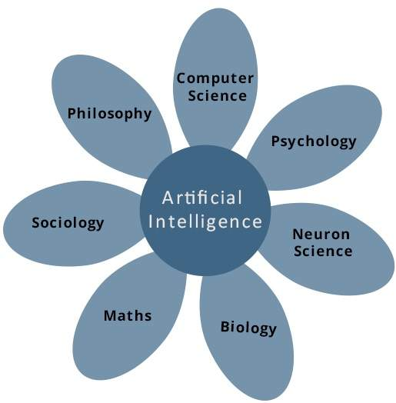
1

What is AI Technique?
In the real world, the knowledge has some unwelcomed properties −
- Its volume is huge, next to unimaginable.
- It is not well-organized or well-formatted.
- It keeps changing constantly.
AI Technique is a manner to organize and use the knowledge efficiently in such a way that −
- It should be perceivable by the people who provide it.
- It should be easily modifiable to correct errors.
- It should be useful in many situations though it is incomplete or inaccurate.
AI techniques elevate the speed of execution of the complex program it is equipped with.
What are the features of artificial intelligence?
The majority of the industries are already started investing in AI and are able to reap the maximum out of it. AI is transforming the day to day life of the common man along with the business world. Now let’s see the add on's in 2019 that has made the AI functioning better compared to 2018.
- Facial recognition
- Artificial Neural networks
- Deep Learning
- Quantum Computing
- Chatbots
Nowadays we are using AI frameworks to communicate with our telephones through Alexa and Siri. cars like Tesla’s decipher and break down their surroundings to insightfully drive themselves. Even Google chooses what sort of query items to give us depending on who it thinks we are. Artificial intelligence is here yet this stage just starts on the grounds that later on AI is going to make a huge difference.

